Query the list of CITY names from **STATION** that either do not start with vowels or do not end with vowels. Your result cannot contain duplicates.

**Input Format**

The **STATION** table is described as follows:

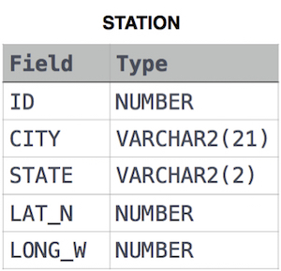

where LAT_N is the northern latitude and LONG_W is the western longitude.

Solution:

SELECT DISTINCT CITY

FROM STATION

WHERE (SUBSTR(CITY,0,1)) NOT IN ('A','E','I','O','U','a','e','i','o','u') OR (SUBSTR(CITY,-1,1)) NOT IN ('A','E','I','O','U','a','e','i','o','u');